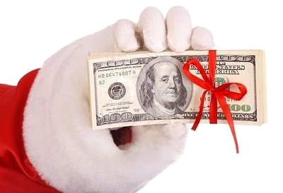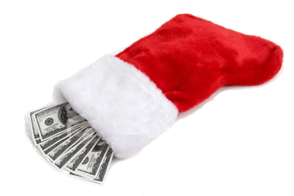

**Christmas Cash**

**Annual Raffle**

**November 6th – December 8th**

The raffle: ***$10 raffle tickets*** – the winning ticket drawn on Tuesday, December 11th, will receive **$1,000 Christmas *CASH*** to put towards shopping and expenses!!

The goal: For each student to sell as many tickets as possible to help their **class** win the competition!

The reward: The top-selling class wins a class party!! You’ll enjoy an afternoon of pizza, games & activities…plus treats to share!

**\*\*Bonus Prize**:** The KW student that sells

the most tickets will win one of these prizes:

Elementary school: a one-night stay at Great Wolf Lodge!

Middle School: a $250 Visa Gift Card

**100% of the proceeds will go to our Covered Grandstands!!**

**_ _ _ _ _ _ _ _ _ _ _ _ _ _ _ _ _ _ _ _ _ _ _ _ _ _ _ _ _ _ _ _ _ _ _ _ _ _ _ _ _ _ _ _ _**

**_____ Yes, I want to sell raffle tickets!**

**Please send me: _____ 5 tickets**

**_____ 10 tickets**

**_____ other amount = _____ tickets**

**Student Name: _________________________ Teacher:** _________

*\*\*Tickets will be given to 8th period teacher by the end of the day\*\**